Lab 3 Creating a Simple UVC

Complete Lab Manual — Cadence Xcelium + UVM

1. Objective

The objective of this lab is to create the front-end of a UVM Verification Component (UVC) and understand the built-in phases of uvm_component.

In this lab, we create a YAPP TX UVC consisting of:

yapp_tx_driver

yapp_tx_sequencer

yapp_tx_monitor

yapp_tx_agent

yapp_env

Then integrate the UVC into the testbench and execute the yapp_5_packets sequence.

2. Required Directory Structure

Start from the main UVM directory:

cd /mnt/hgfs/uvm

The Lab 3 directory should be:

lab03_uvc/

├── sv/

│ ├── yapp_packet.sv

│ ├── yapp_pkg.sv

│ ├── yapp_tx_seqs.sv

│ ├── yapp_tx_driver.sv

│ ├── yapp_tx_sequencer.sv

│ ├── yapp_tx_monitor.sv

│ ├── yapp_tx_agent.sv

│ └── yapp_env.sv

│

└── tb/

├── router_tb.sv

├── router_test_lib.sv

├── top.sv

└── run.f

Check:

ls

Then:

cd lab03_uvc

ls

Expected:

sv tb

3. Copy Lab 2 Files

cd /mnt/hgfs/uvm

cp -R lab02_test/* lab03_uvc/

Then:

cd lab03_uvc

Check:

ls

4. Check UVM Installation

Check the UVM environment variable:

echo $UVMHOME

Expected similar output:

/usr/Software/CadenceTools/XCELIUM2409/tools/methodology/UVM/CDNS-1.1d

5. Create yapp_tx_driver.sv

Go to the sv directory:

cd /mnt/hgfs/uvm/lab03_uvc/sv

Create the driver:

nano yapp_tx_driver.sv

Enter:

class yapp_tx_driver extends uvm_driver #(yapp_packet);

`uvm_component_utils(yapp_tx_driver)

function new(string name = "yapp_tx_driver",

uvm_component parent = null);

super.new(name, parent);

endfunction

virtual task run_phase(uvm_phase phase);

forever begin

seq_item_port.get_next_item(req);

send_to_dut(req);

seq_item_port.item_done();

end

endtask

virtual task send_to_dut(yapp_packet packet);

`uvm_info("YAPP_TX_DRIVER",

$sformatf("Packet is \n%s", packet.sprint()),

UVM_LOW)

#10ns;

endtask

endclass

Save:

Ctrl + O

Enter

Ctrl + X

Verify:

cat yapp_tx_driver.sv

6. Create yapp_tx_sequencer.sv

nano yapp_tx_sequencer.sv

Enter:

class yapp_tx_sequencer extends uvm_sequencer #(yapp_packet);

`uvm_component_utils(yapp_tx_sequencer)

function new(string name = "yapp_tx_sequencer",

uvm_component parent = null);

super.new(name, parent);

endfunction

endclass

Save and check:

cat yapp_tx_sequencer.sv

7. Create yapp_tx_monitor.sv

nano yapp_tx_monitor.sv

Enter:

class yapp_tx_monitor extends uvm_monitor;

`uvm_component_utils(yapp_tx_monitor)

function new(string name = "yapp_tx_monitor",

uvm_component parent = null);

super.new(name, parent);

endfunction

virtual task run_phase(uvm_phase phase);

`uvm_info("YAPP_TX_MONITOR",

"You are in the YAPP TX monitor",

UVM_LOW)

endtask

endclass

Save:

8. Create yapp_tx_agent.sv

The agent contains:

agent

├── driver

├── monitor

└── sequencer

Create:

nano yapp_tx_agent.sv

Enter:

class yapp_tx_agent extends uvm_agent;

`uvm_component_utils_begin(yapp_tx_agent)

`uvm_field_enum(uvm_active_passive_enum, is_active, UVM_ALL_ON)

`uvm_component_utils_end

yapp_tx_monitor monitor;

yapp_tx_driver driver;

yapp_tx_sequencer sequencer;

function new(string name = "yapp_tx_agent",

uvm_component parent = null);

super.new(name, parent);

endfunction

virtual function void build_phase(uvm_phase phase);

super.build_phase(phase);

monitor = yapp_tx_monitor::type_id::create("monitor", this);

if (is_active == UVM_ACTIVE) begin

driver = yapp_tx_driver::type_id::create("driver", this);

sequencer = yapp_tx_sequencer::type_id::create("sequencer", this);

end

endfunction

virtual function void connect_phase(uvm_phase phase);

if (is_active == UVM_ACTIVE) begin

driver.seq_item_port.connect(sequencer.seq_item_export);

end

endfunction

endclass

Save and verify:

cat yapp_tx_agent.sv

9. Create yapp_env.sv

The environment contains the YAPP TX agent.

nano yapp_env.sv

Enter:

class yapp_env extends uvm_env;

`uvm_component_utils(yapp_env)

yapp_tx_agent agent;

function new(string name = "yapp_env",

uvm_component parent = null);

super.new(name, parent);

endfunction

virtual function void build_phase(uvm_phase phase);

super.build_phase(phase);

agent = yapp_tx_agent::type_id::create("agent", this);

endfunction

endclass

Save and check:

cat yapp_env.sv

10. yapp_pkg.sv

First inspect the existing package:

cat yapp_pkg.sv

It should contain the package declaration and UVM import.

Open it:

nano yapp_pkg.sv

The include order is important.

Use:

package yapp_pkg;

import uvm_pkg::*;

`include "uvm_macros.svh"

`include "yapp_packet.sv"

`include "yapp_tx_monitor.sv"

`include "yapp_tx_sequencer.sv"

`include "yapp_tx_seqs.sv"

`include "yapp_tx_driver.sv"

`include "yapp_tx_agent.sv"

`include "yapp_env.sv"

endpackage : yapp_pkg

11. router_tb.sv

Go to:

cd ../tb

Open:

nano router_tb.sv

The testbench should contain a handle for yapp_env.

Use:

class router_tb extends uvm_env;

`uvm_component_utils(router_tb)

yapp_env yapp;

function new(string name = "router_tb",

uvm_component parent = null);

super.new(name, parent);

endfunction

virtual function void build_phase(uvm_phase phase);

super.build_phase(phase);

yapp = yapp_env::type_id::create("yapp", this);

`uvm_info("ROUTER_TB",

"Build phase of the testbench is being executed",

UVM_HIGH)

endfunction

endclass

Save.

12. router_test_lib.sv

Open:

nano router_test_lib.sv

Use:

class base_test extends uvm_test;

`uvm_component_utils(base_test)

router_tb tb;

function new(string name = "base_test",

uvm_component parent = null);

super.new(name, parent);

endfunction

virtual function void build_phase(uvm_phase phase);

super.build_phase(phase);

uvm_config_wrapper::set(this,

"tb.yapp.agent.sequencer.run_phase",

"default_sequence",

yapp_5_packets::get_type());

tb = router_tb::type_id::create("tb", this);

`uvm_info("BASE_TEST",

"Build phase of the test is being executed",

UVM_HIGH)

endfunction

virtual function void end_of_elaboration_phase(uvm_phase phase);

uvm_top.print_topology();

endfunction

endclass

class test2 extends base_test;

`uvm_component_utils(test2)

function new(string name = "test2",

uvm_component parent = null);

super.new(name, parent);

endfunction

endclass

13. top.sv

Open:

nano top.sv

The Lab 2 random packet generation code should be removed.

Use:

module top;

import uvm_pkg::*;

`include "uvm_macros.svh"

import yapp_pkg::*;

`include "router_tb.sv"

`include "router_test_lib.sv"

initial begin

run_test();

end

endmodule : top

14. Check All Files

Go to sv:

cd ../sv

Run:

ls

Expected:

yapp_env.sv

yapp_packet.sv

yapp_pkg.sv

yapp_tx_agent.sv

yapp_tx_driver.sv

yapp_tx_monitor.sv

yapp_tx_seqs.sv

yapp_tx_sequencer.sv

Then:

cd ../tb

Run:

ls

Expected:

clean

qaLog.txt

router_tb.sv

router_test_lib.sv

run.f

top.sv

xcelium.d

xrun.history

xrun.log

15. Configure run.f

Open:

nano run.f

Use:

-64

-uvmhome $UVMHOME

-incdir ../sv

../sv/yapp_pkg.sv

top.sv

+UVM_TESTNAME=base_test

+UVM_VERBOSITY=UVM_HIGH

Save.

Check:

cat run.f

16. Compile and Run

From:

/mnt/hgfs/uvm/lab03_uvc/tb

run:

xrun -f run.f

17. Check the UVM Topology
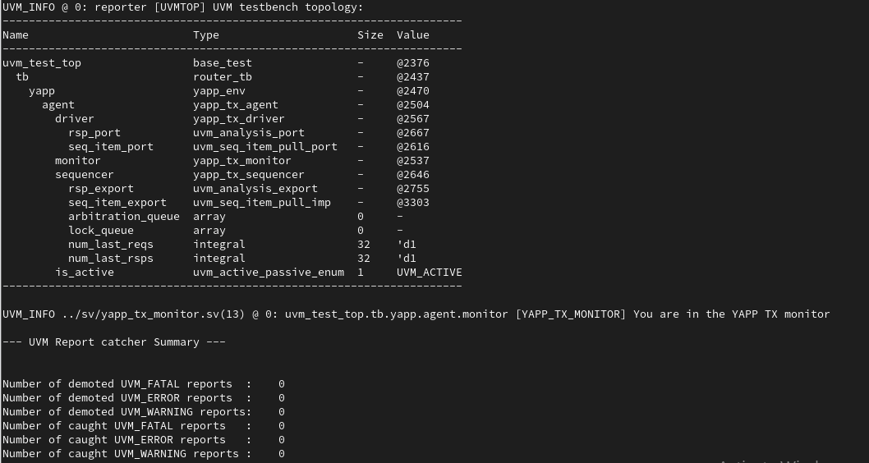

18. Answer the Lab Questions

Question 1

Does the hierarchy match your expectations?

Answer:

Yes. The topology contains the base_test, router_tb,

yapp_env, yapp_tx_agent, driver, monitor and sequencer

in the expected UVM hierarchy.

Question 2

Sequencer pathname:

tb.yapp.agent.sequencer

Question 3

Value of is_active:

UVM_ACTIVE

This means the agent contains both:

driver

sequencer

as well as the monitor.

19. Verify yapp_5_packets
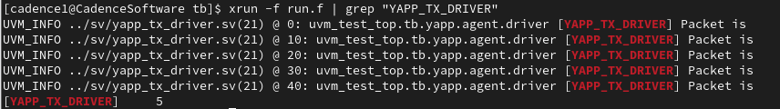

20. Run the Sequence
Go back:
cd ../tb
Run:
xrun -f run.f

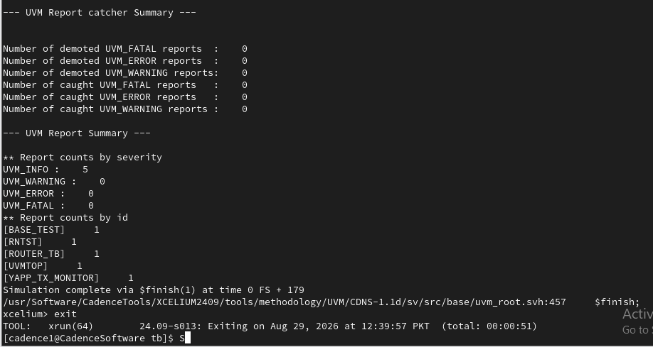

21. Verify Exactly 5 Packets
A useful command is:
xrun -f run.f | grep "YAPP_TX_DRIVER"
Or:
xrun -f run.f | grep -c "YAPP_TX_DRIVER"
The second command gives the number of driver packet messages.

22. Use a Random Seed
Add this to the end of run.f:
+SVSEED=random
Your final run.f should be:
-64

-uvmhome $UVMHOME

-incdir ../sv

../sv/yapp_pkg.sv
top.sv

+UVM_TESTNAME=base_test
+UVM_VERBOSITY=UVM_HIGH
+SVSEED=random
Run:
xrun -f run.f

